

**Mathematics Specialist**

**Test 4 2016**

**Integration Techniques &**

**Applications of Integral Calculus**

**NAME: _______________________________________________ TEACHER: MLA**

**Resource Free Section**

**30 marks**

**30 minutes**

**Question 1 [3, 3 & 3 = 9 marks]**

Determine the following indefinite integrals:

(a) $\int{{5 tan}^{2}\left(5x\right) dx}$

(b) $\int{27\tan^{2}\left(3x\right)\sec^{2}\left(3x\right) dx}$

(c) $\int{{8 sin}^{2}\left(2x\right) dx}$

**Question 2 [5 marks]**

Use the substitution $u=1+sin⁡(x)$ to evaluate $\int_{0}^{\frac{π}{2}}{\frac{4cos⁡(x)}{\sqrt{1+sin⁡(x)}}}$

**Question 3 [3 & 3 = 6 marks]**

1. $If f '(x)=\cos\left(x\right)\sin\left(2x\right)$, determine f(x).
2. Hence, calculate the area between the curve $y=\cos\left(x\right)\sin\left(2x\right)$ and the x-axis from

$x=-\frac{π}{2} to x=π$.

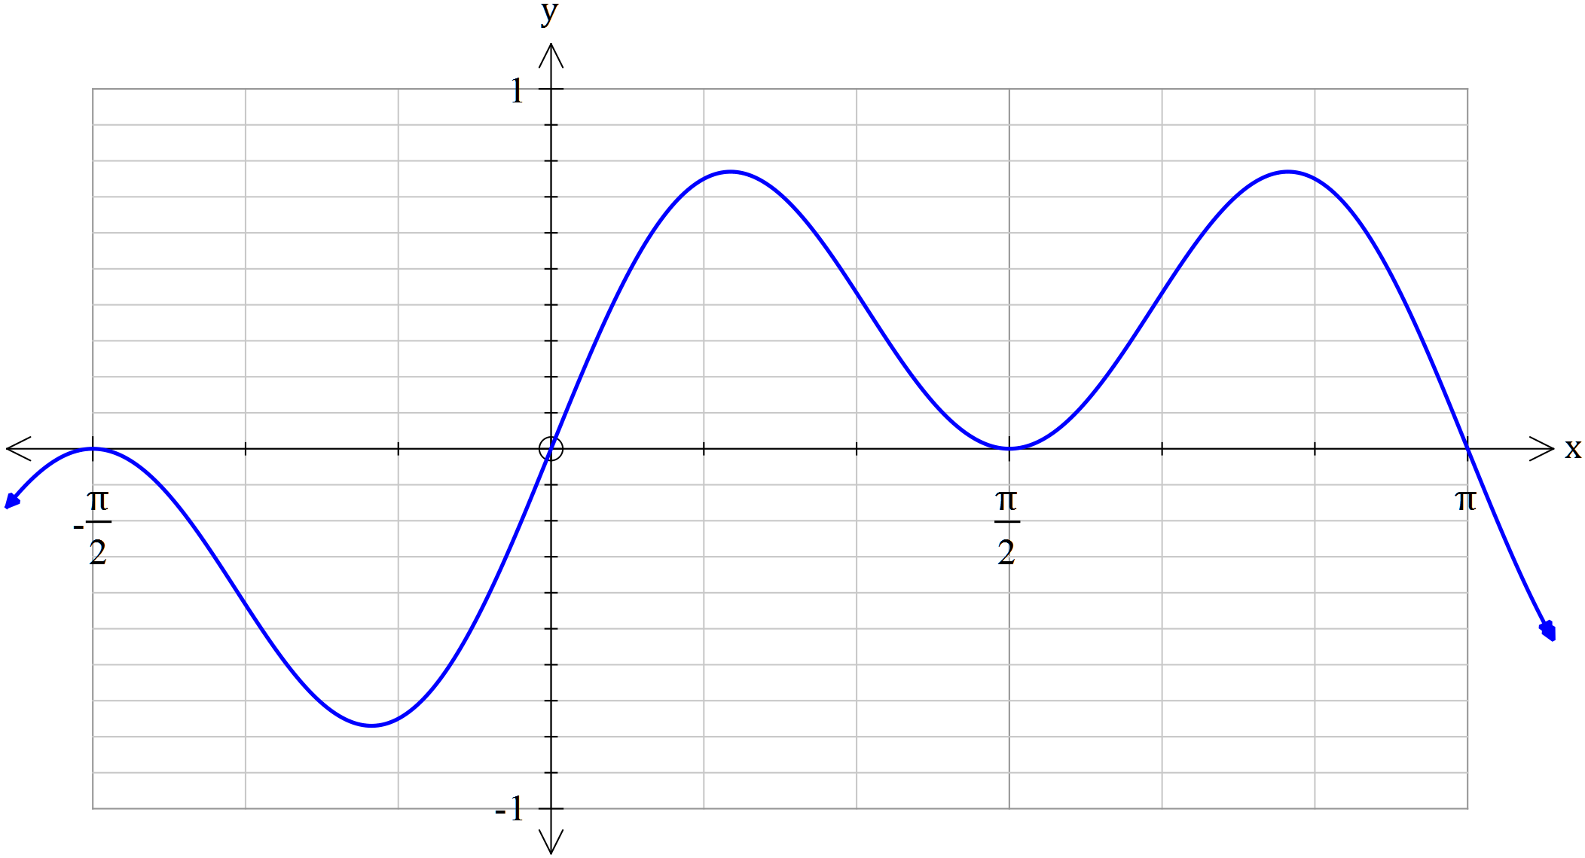

$$y=\cos\left(x\right)\sin\left(2x\right)$$

**Question 4 [5 marks]**

Calculate the exact volume generated by revolving the area trapped $between y=\frac{1}{x^{2}-1} ,$ the vertical axis and the lines $y=-e^{2}$ and $y=-1 about the y axis.$



$$y=\frac{1}{x^{2}-1}$$

**Question 5 [2 & 3 = 5 marks]**

(a) If $y=ln⁡(x^{x^{2}})$, determine $\frac{dy}{dx}$

Hint 1: Apply a suitable log law to $y=\ln\left(x^{x^{2}}\right)$ before differentiating

Hint 2: Do not factorise your final answer

(b) Hence, find $\int{2x\ln\left(x\right) dx}$



**Mathematics Specialist**

**Test 4 2016**

**Integration Techniques &**

**Applications of Integral Calculus**

**NAME: _______________________________________________ TEACHER: MLA**

**Resource Rich Section**

**20 marks**

**20 minutes**

**One unfolded A4 page of notes, SCSA formulae booklet and ClassPad calculator permitted**

**Question 6 [1 & 1 = 2 marks]**

(a) Express $\int{\frac{x^{2}-x+1}{(x+3)(x^{2}+4)}} dx ,$ in exact terms

(b) Evaluate $\int_{0}^{4π}{\frac{x^{2}-x+1}{(x+3)(x^{2}+4)}} dx , correct to 2 decimal places$

**Question 7 [6 marks]**

Use your knowledge of partial fractions to determine $\int{\frac{7x^{2}-2x+5}{(x-1)(x^{2}+1)}} dx$

Show clear working.

**Question 8 [3, 2, 2 & 1 = 8 marks]**

Consider the functions $f\left(x\right)=\frac{\sqrt{x} (x^{2}-5x)}{ 2} and g\left(x\right)=-3\sqrt{x}$

A, B and (0, 0) are the three points of intersection of the aforementioned functions.

(a) Draw a neat sketch of f(x) and g(x) on the axes below. Label points A and B.

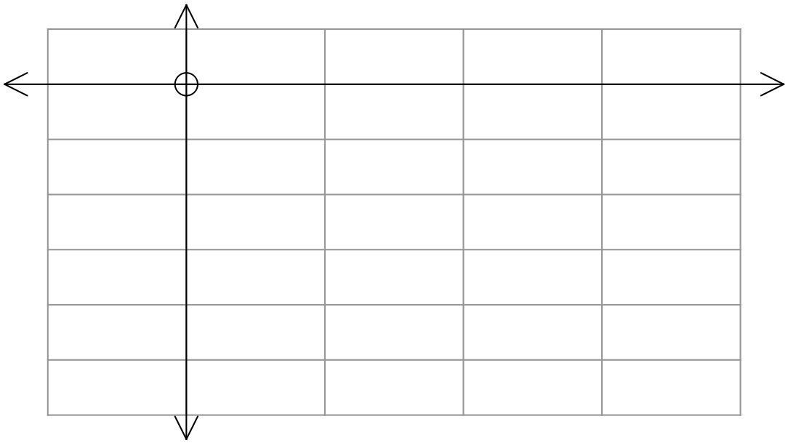

(b) State the ordered pairs for points A and B, correct to 2 decimal places.

(c) State the definite integral that defines the area enclosed by f(x) and g(x) between points A and B.

(d) Use your Classpad to determine the area described in (c).

**Question 9 [4 marks]**

In geometry, a torus is a surface of revolution generated by revolving a circle in 3-dimensional space about an axis co-planar with the circle.

[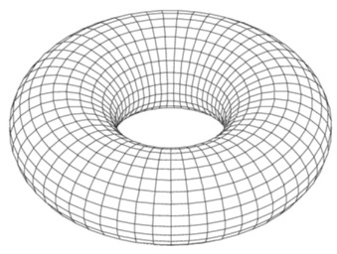](https://www.google.com.au/url?sa=i&rct=j&q=&esrc=s&frm=1&source=images&cd=&cad=rja&uact=8&ved=0CAcQjRxqFQoTCInilOmS58cCFaLlpgodub8Pzw&url=https://mycqstate.wordpress.com/2013/10/01/quantum-pcp-a-survey/&psig=AFQjCNF_oETq3iNUHp1-M_bF0Wsz9cna1Q&ust=1441791632769267)

Use calculus to determine the volume of the torus formed by rotating the circle with equation ${ x}^{2}+{(y-2)}^{2}=1$ about the x-axis.